class WrongAgeException extends Exception
{
WrongAgeException(String msg)
{

super(msg);
System.out.println(msg);
}
}

class Father
{
int fage;
Father(int age) throws WrongAgeException
{
if (age<0)
throw new WrongAgeException("Father age cannot be negative");
fage=age;

}
}

class Son extends Father
{
int sage ;
Son(int fage , int sage ) throws WrongAgeException
{
super(fage);
if(fage<sage)
throw new WrongAgeException("Father age cannot be less than son's age");
if(sage<0)
throw new WrongAgeException("Son age cannot be negative");
this.sage=sage;
}

public void display()
{
System.out.println("Father age :" + fage);
System.out.println("Son age : "+sage);
}
}

public class Excdemo
{
public static void main(String[] args) {
try{
Son obj3 = new Son(40,20);
obj3.display();
Son obj = new Son(40, 50);
obj.display();

}
catch(Exception e)
{
System.out.println("Exception caught :"+e);
}

}
}

OUTPUT
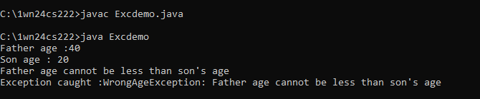

Code block for negative age

public class Excdemo
{
public static void main(String[] args) {
try{

Son obj2 = new Son(40,-20) ;
obj2.display();

}
catch(Exception e)
{
System.out.println("Exception caught :"+e);
}

}
}

OUTPUT
